PYTHON PROGRAMMING:

IMPORTANT KEY POINT:

1. Every programs have grammatical rules.
2. Language of computer is java, python, c++.
3. Calculated problem become easier.

Data is binary code in pc.

1. The data store as in the variable i.e temporary storage base.
2. Variable has data and name and address where it store in memory.
3. We perform multiple operation in variable such as +-,-,*,%,/.

IF-ELSE:

1. We also do decision by using variables and statement and condition.
2. Main parts are if, else and ifelse.

e.g

print("hello what is your name?");

x=input();

if x=='seher':

print(x);

else:

print("name is not seher");

ELIF:

print("hello what is your name?");

x=input();

if x=='seher':

print(x);

elif:

print("name is not seher");

LOOP:

1. Loop statement are used to repeat task.

While Loop:

# while loop

i = 0

while i < len(value):

print(x)

if i == len(value) - 1:

break

i += 1

For Loop:

# use of range() to defin

e a range of values

values = range(4)

# iterate from i = 0 to i = 3

for i in values:

print(i)

Do while loop:

while True:

# code to be executed

# check if the condition is met to exit the loop

if condition:

break

FOR-ELSE:

digits = [0, 1, 5]

for i in digits:

print(i)

else:

print("No items left.")

FUNCTION:

1. It is a block of code which perform specific task.

OOP CONCEPT:

1. CLASSES:

Template/blue print for real world entities.

1. OBJECTS:

Specific instances of class.

ALGORITMS:

It’s step by step approach to solve a programming question.

PYTHON INTRO:

FREE OPEN SOURCE PROGRAMMING LANGUAGE OPEN SOURCE.it is a standard library. Have oop concept. Cross platform compatible.

DOWNLOAD:

Download pycharm, anaconda for data science practitioners and data visualization and Jupyter notebook.

SIMPLE INPUT:

print("hello what is your name?");

x=input();

print(x);

JUPYTER INTRO:

Browser-based interpreter that allow us to interactively work with python.in this kernel is the executer of the program. We work by adding cell.

VARIABLE AND DATA TYPES:

INITIALIZING VARIABLE:

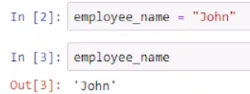

We can change variable name.

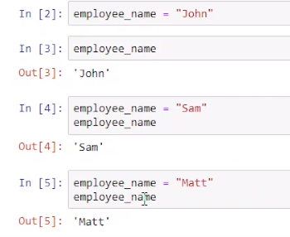

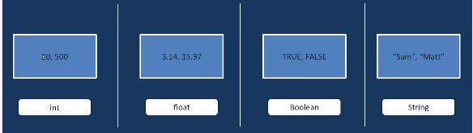DATATYPES:

To check data type

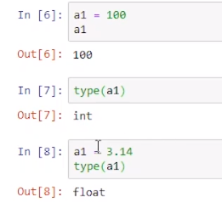

Complex number in python:

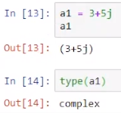

OPERATOR:

1. ARITHEMATIC OPERATOR:

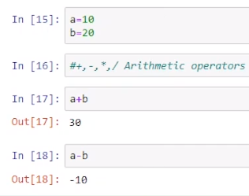

1. RELATIONAL OPERATOR:

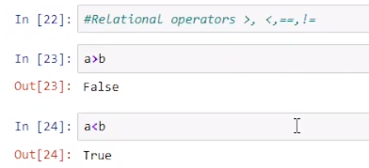

1. LOGICAL OPERATOR:

AND: both condition should true.

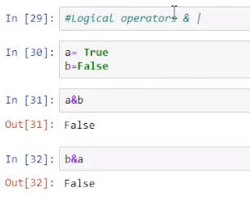

OR: even single true value give true.

TOKENS:

Smallest meaningful component in a program.

1. KEYWORDS:

Special reserve words. These are unique words.

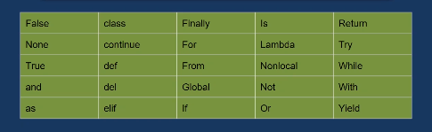

1. IDENTIFIERS:

Use for variables, functions and objects.

RULES:

No special character except (_).

They are case sensitive.

First letter cannot be digit.

Ex.

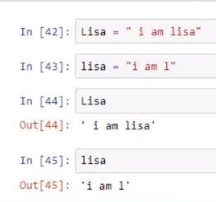

1. LITERALS:

Literals are constant. They cannot be damage.

1. OPERATORS:

Already study.

STRINGS:

Sequence of character.

Ex.

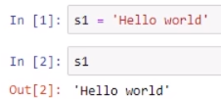

MULTILINE STRING:

EX.

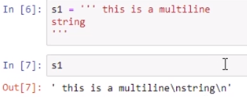

EXTRACTING SINGLE CHARATER:

Indexing start with 0.

EX.

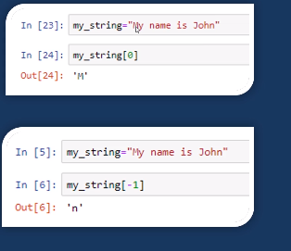

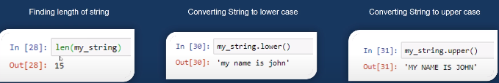SOME SPECIAL CASE:

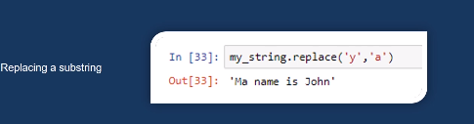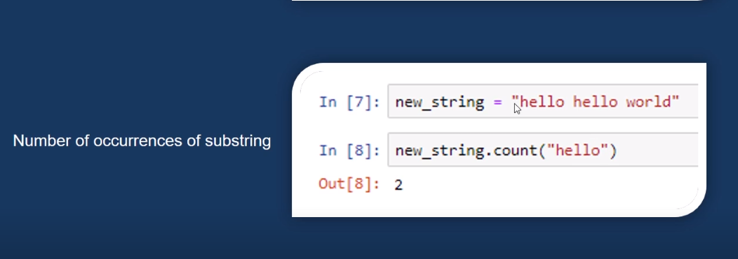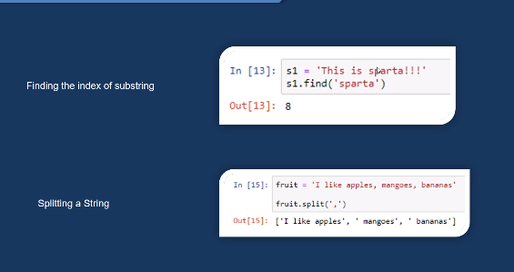

DATA-STRUCTURE IN PYTHON:

1. Tuple.
2. List.
3. Dictionary.
4. Set.
5. TUPLE:

It is an order collection of element enclosed in (0).once we create it we can not change it that is why it is called immutable. Similar to structures.

Ex.

Tup1={1,’a’,True}

*CANCATINATION OF TUPLE:

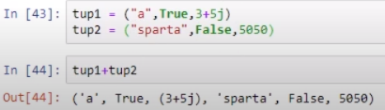Sequence matter.

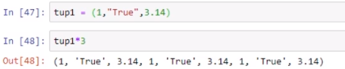*REPETING TUPLE ELEMENT:

*MINIMUM VALUE AND MAXIMUM VALUE:

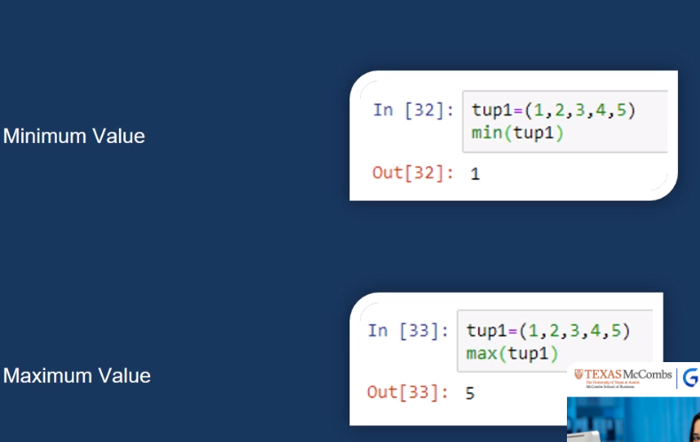2) LIST:

List is an ordered collection of element enclosed in [].

List are mutable.

Ex.

L1= [1, 2, 2.3, ’a’, 3+3j]

REMAIN THINGS ARE SAME.

SOME SPECIAL FUNCTIONS:

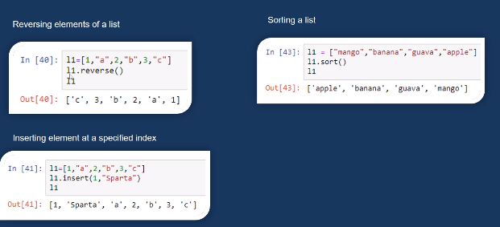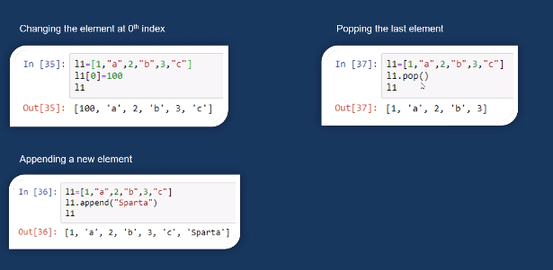

1. DICTIONARY:

Dictionary is an unordered collection of key-value pairs enclosed with {}. It is mutable.

Ex. Fruit= {“APPLE”:10, “ORANGE”:20}

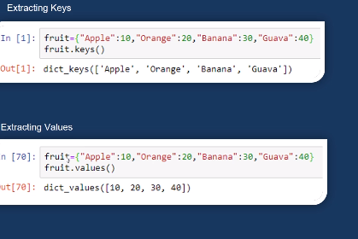*EXTRACTING KEY AND VALUES:

And if you want both key and value at the same time write.

Dictionary name.item()

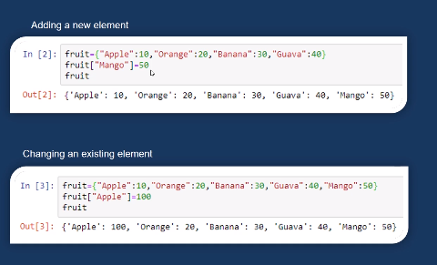*MODIFICATION:

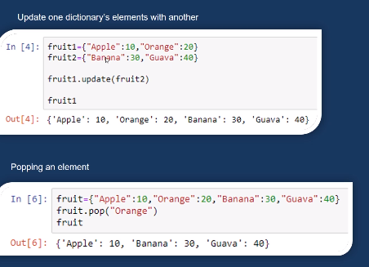

1. SET:

UNINDEX COLLECTION OF ELEMNT ENCLOSED IN{}.

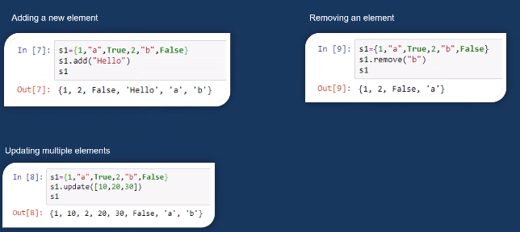*modification:

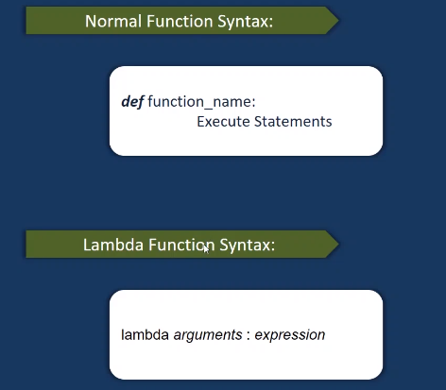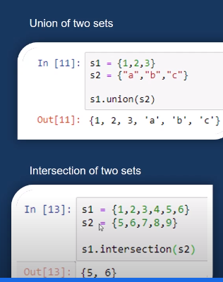FUNCTIONS :

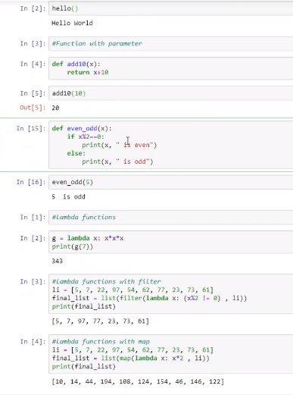EXAMPLE:

TYPE CASTING:

Str()=any data type into string

Int()=any data type into integer

Float()=any data type into float

Ord(),hex(),oct(),tuple(),set(),dic()